## The E-Waste Deception: What Tech Giants Don’t Want You to Know

Each year, the world discards enough electronics to circle the Earth 48 times. Beneath the surface of responsible recycling lies a darker truth. This includes toxic dumping, lost data, and corporate cover-ups.

### The Scale of the Crisis (with Real Data)

The world generates 57.4 million metric tons of electronic waste each year. That’s enough to:

* Wrap discarded laptops around the equator 48 times.
* Fill **1.5 million** 40-ton trucks—a convoy stretching from **New York to Mumbai.**

**Why this matters:**

* One cracked phone screen can pollute 58,000 liters of groundwater with mercury.
* Burning copper cables in Ghana releases **6× more carcinogens** than the WHO safety limit
* 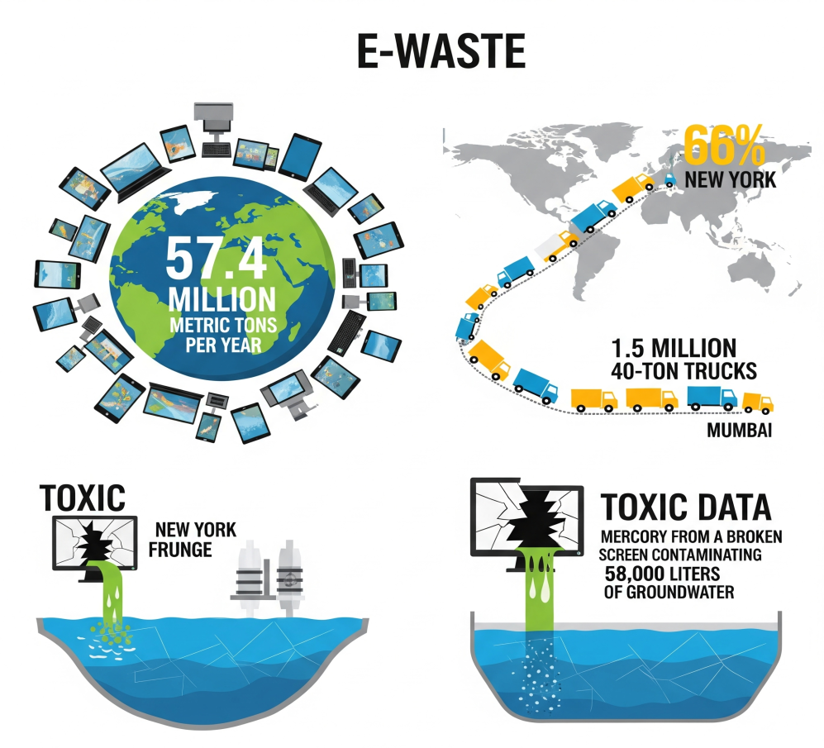

### Part 1: The Recycling Charade

Certified Programs That Betray Trust

Major retailers have not fulfilled their recycling promises to the public.

**Company & Year** **Public Claim** **What Investigators Found** **Consequence**

Best Buy, 2021: “All electronics responsibly recycled.” CBS News discovered devices in Indonesian scrap yards. EPA fine: $2.3 million

Staples and Earth Sense found that 32% of tracked devices ended up in Malaysian dumps. There was public backlash, but no legal fine was imposed.

The Export Playbook: How the Scam Works

1. Devices are collected under the label of **domestic recycling**
2. They’re reclassified as **“used goods”** to dodge international waste laws
3. Shipped overseas to countries with weak environmental oversight
4. Recyclers profit: ~$4.50 scrap value/device vs $20 to process safely in the U.S.
5. 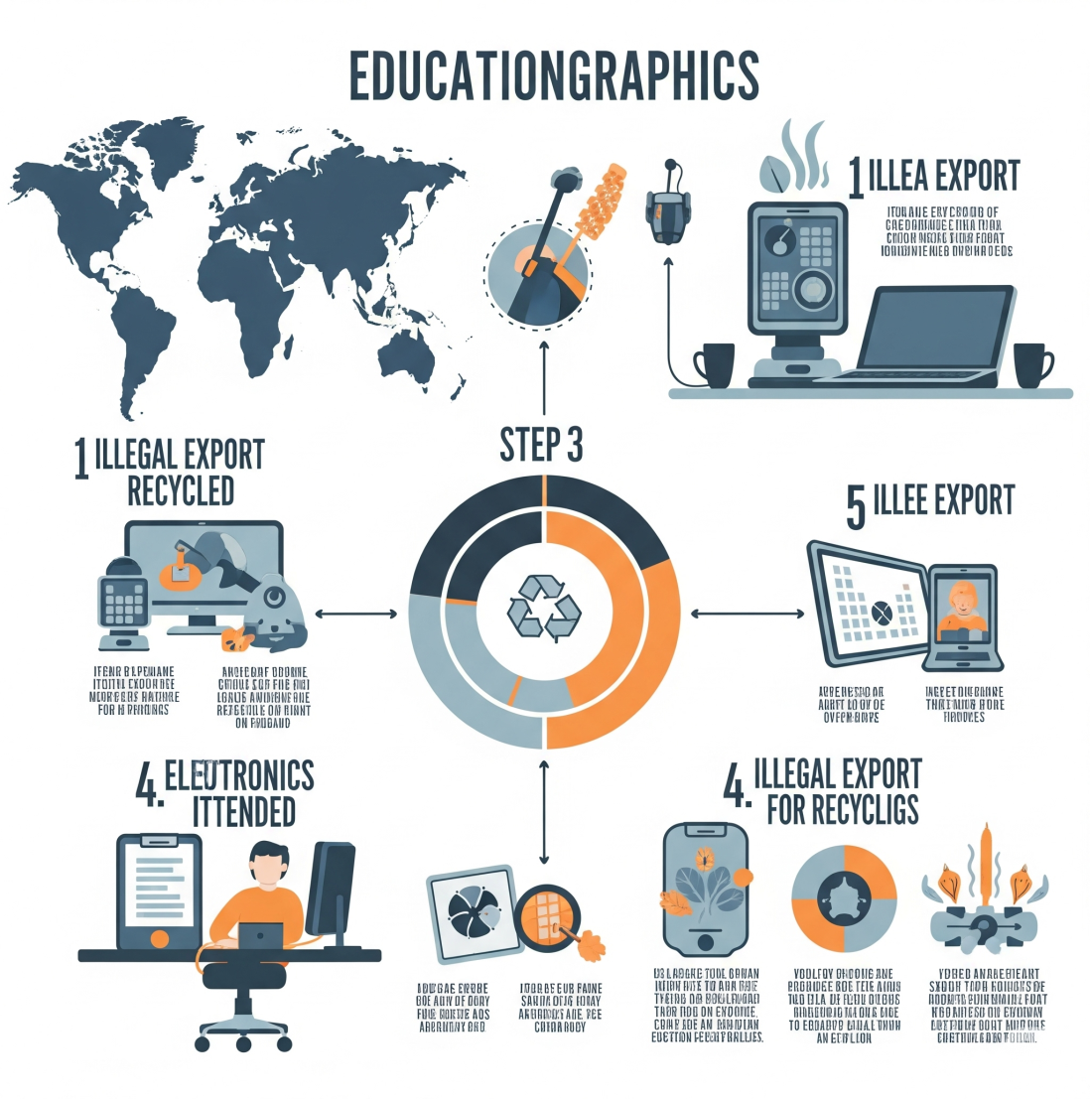

### Part 2: Your Data at Risk

Recycling your device without wiping data can risk your digital identity.

A 2023 study from the University of California looked at 200 “wiped” devices bought on eBay and Facebook Marketplace.

* **63%** still contained personal documents or photos
* **22%** had active logins to email, cloud storage, or banking apps
* **9%** contained full identity records like passports or tax files

**How to Wipe Devices Properly**

| **Device Type** | **Recommended Tool** | **Effectiveness** | **Time Required** |
| --- | --- | --- | --- |
|  |  |  |  |
|  |  |  |  |
| Windows PC | DBAN (Darik's Boot and Nuke) | 99.9% | 2–8 hours |
| Mac (SSD) | Disk Utility (3-pass erase) | 98% | 1–4 hours |
| Android | Encrypt + Factory Reset | 95% | ~30 minutes |
| iPhone | iOS Erase (with encryption) | 99% | ~10 minutes |

Most factory resets do **not** fully erase encrypted data unless the device was encrypted first.

### Part 3: The Ethical Way Forward

Recycling can work—but only with partners who are transparent, certified, and audit-compliant.

Certified Recyclers That Can Be Trusted

1. **e-Stewards Certified Facilities**
   * No exports, no prison labor, full audit trail
   * Ideal for businesses and secure personal data disposal
2. **Dell Reconnect**
   * Free drop-off at over 1,200 Goodwill locations
   * Publishes annual recovery reports and partners with verified smelters
3. **Call2Recycle (Batteries Only)**
   * 97% material recovery rate
   * Public list of certified downstream partners
   * 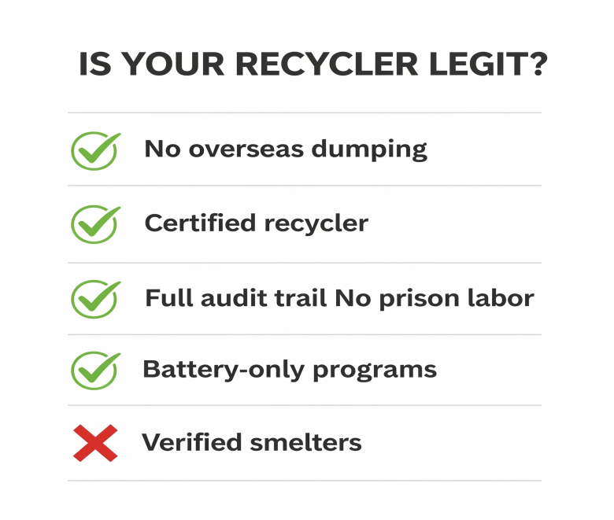

### Better Than Recycling: The Five-Year Device Pyramid

Most devices don't need to be recycled immediately. Consider these options—**recycling should be the last resort**:

1. **Repair**
   * Use iFixit guides to fix over 80% of common hardware issues
2. **Resell**
   * Sites like Swappa pay 2–3× more than Gazelle or trade-in programs
3. **Repurpose**
   * Convert old phones into security cameras with apps like **Alfred**
4. **Donate**
   * Digitunity connects working devices with schools and nonprofits
5. **Recycle**
   * Only use certified programs like **e-Stewards** or **Dell Reconnect**
   * 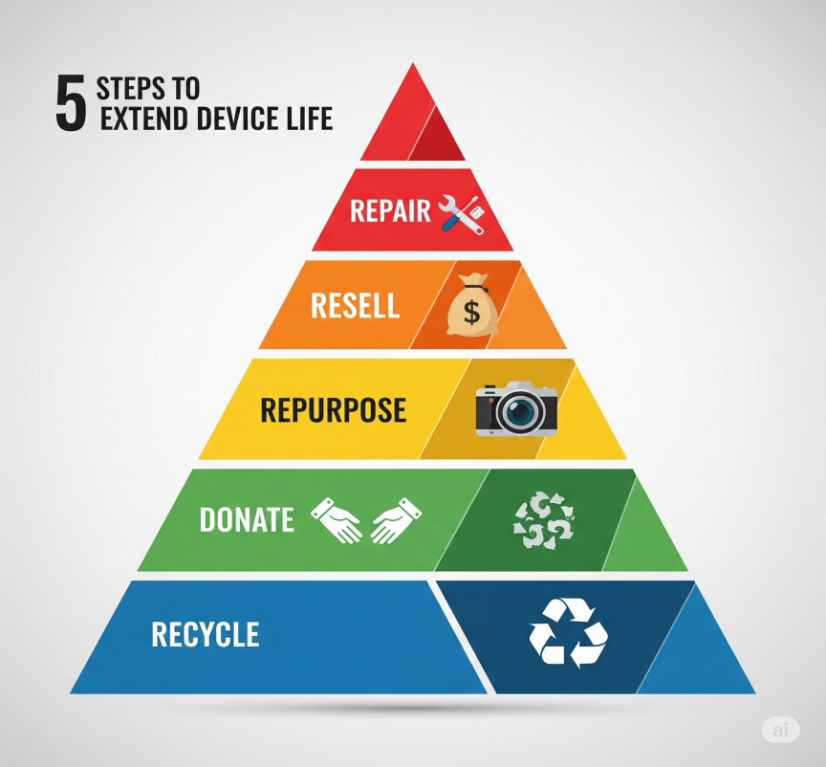

### The Future: Real Solutions in Motion

The e-waste crisis can be reversed—but only with the right innovations and policies:

**1. Urban Mining Robots**

* Apple’s “Daisy” robot recovers 1 ton of gold per 100,000 iPhones
* Redwood Materials extracts 95% of lithium from EV batteries

**2. Right-to-Repair Laws**

* The EU (2024) requires 10-year parts availability for electronics
* Colorado (2023) banned software “parts pairing” that disables DIY repair

**3. Blockchain-Based Tracking**

* Norway’s pilot project traces devices from collection bins to final smelters
* Prevents illegal “disappearances” during shipment or processing

### Your 7-Day E-Waste Action Plan

Days 1–3: Audit Your Tech Graveyard Look in drawers, closets, basements, and office shelves for unused electronics.

**Day 4: Wipe Your Data** Securely erase two devices per day using the wiping tools listed earlier.

Day 5: Choose a Path You can either resell them. Use Swappa or Facebook Marketplace. Or, book a pickup with a certified e-Stewards recycler.

**Days 6–7: Raise Your Voice** Email or tag electronics brands asking:

“Where does your e-waste really go?”

Consumer pressure has already forced changes—yours can too.

### Final Thought

The recycling system isn’t broken—it’s been rigged. Corporations hide behind certifications and PR slogans while exporting risk and pollution elsewhere. But you don’t have to play along.

Make smart choices and ask for transparency. This way, you can protect your data, cut global harm, and support an ethical tech economy—one device at a time.